**Big Bang integration**

* Consider a case where you are working for vintage systems where we are developing ecommerce application in Waterfall model  
  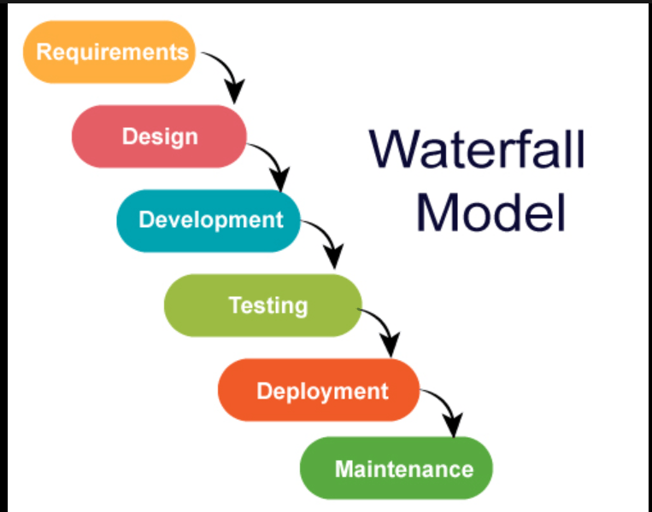

Application is in layered architecture

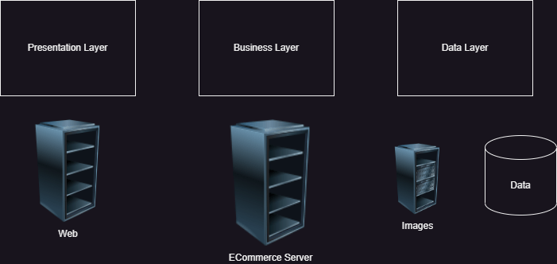

We have team managers

* Andy
* Brian
* Cathy  
  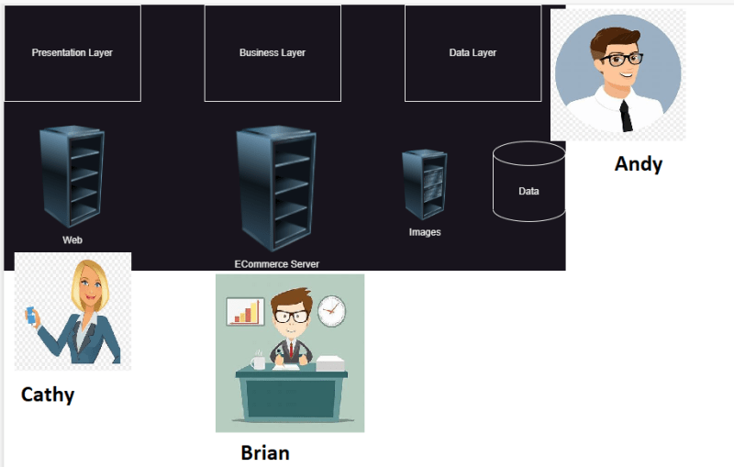
* Project has to be finished in a year
* Each team works independently for 9 months and finishes the development  
  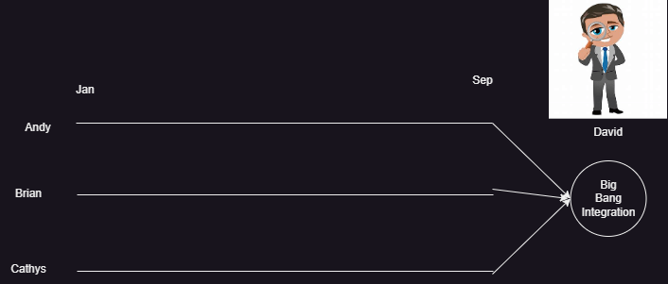
* Big Bang integrations are error prone, so best solution would be continuos integration (CI).
* The Goal of CI is to inform dev teams about the failures of integration.
* To perform CI different tools started like cruise control and hudson/jenkins
* Need for automated tests/unit tests started at this point.

**Agile way of Software Development**

* Agile had added smaller and frequent releases, this needs more aggressive automations than CI.
* Expectation:
  + Automated Pipeline which when developer pushes changes
    - Build/Package code
    - Code Quality and Security Issues
    - Automate test executions with System, Performance, Reliablity, Security
    - Report of the Quality of work done yesterday
  + Customer and Internal Releases every 2 weeks

